**Supplementary Material.**

**Supplementary Figures.**

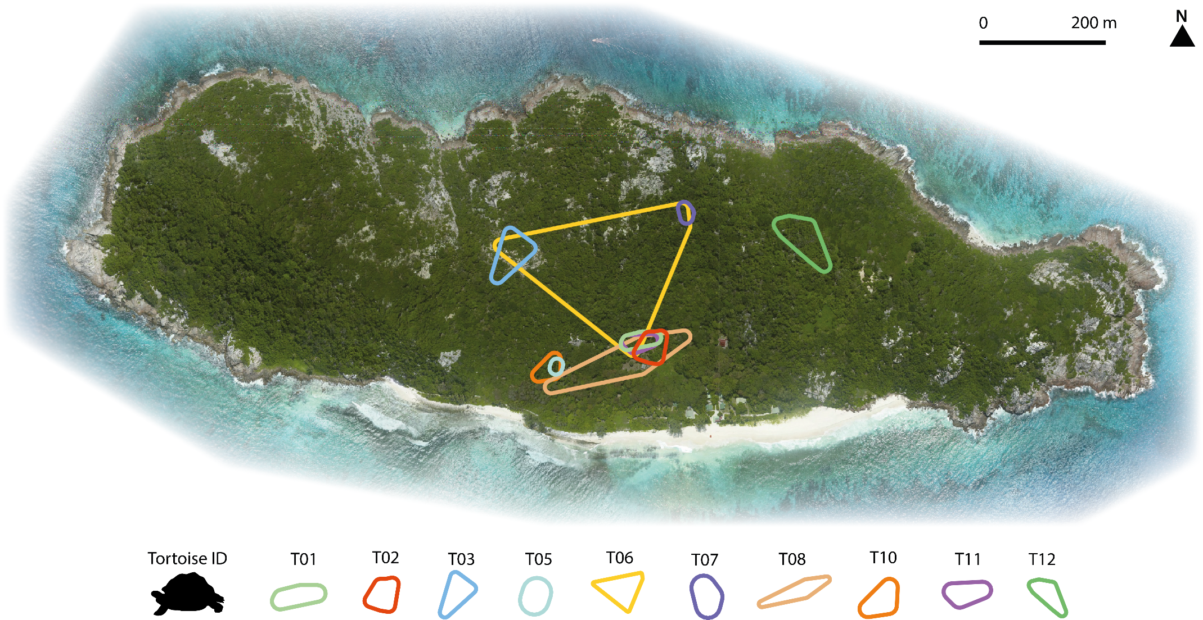

**Fig. S1.** Feeding areas of the ten individual tortoises introduced on Aride Island during sampling period.

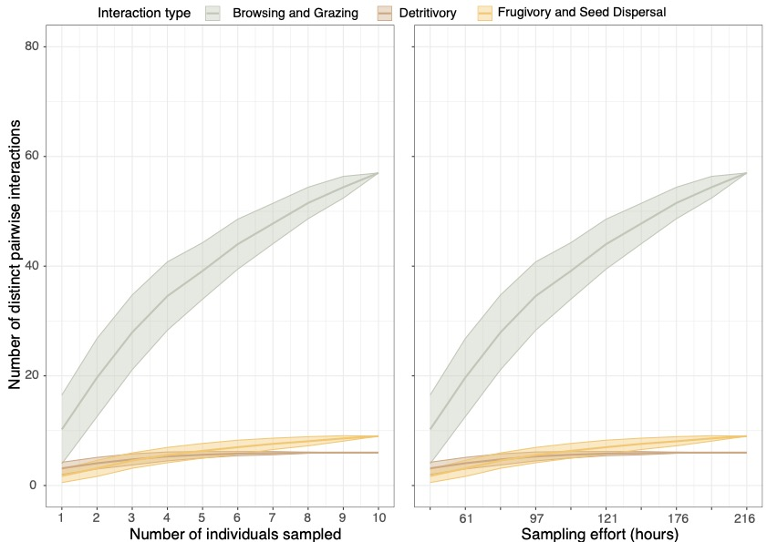

**Fig. S2.** Interaction accumulation curves depicting sampling completeness. Panel A shows the relationship between the number of distinct pairwise interactions recorded in relation to the number of tortoise individual sampled (left panel) and the number of sampling hours (right panel) for detritivory (brown), browsing and grazing (green) and frugivory and seed dispersal (yellow).

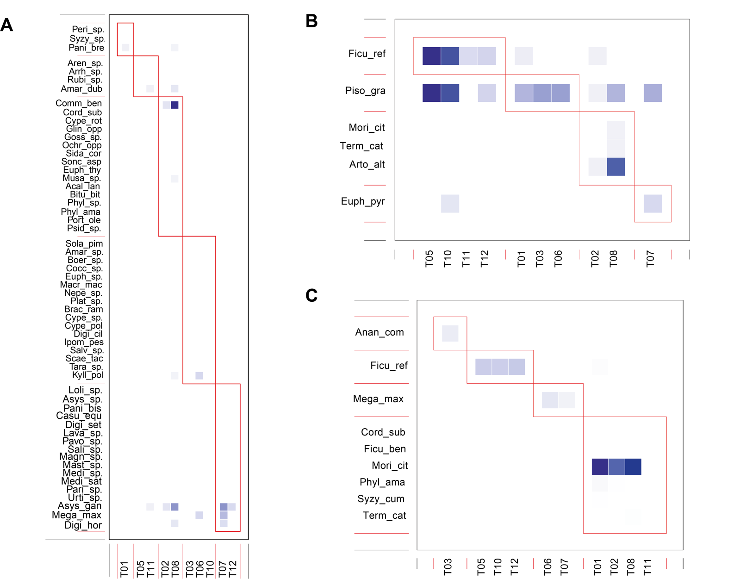

**Fig. S3.** Modules from individual-based networks for (A) browsing and grazing, (B) detritivory and (C) frugivory and seed dispersal.

**Supplementary Tables.**

**Table S1.** List of 154 plant species historically recorded on Aride Island, including 80 native species and 74 introduced species.

|  |  |
| --- | --- |
| NATIVE SPECIES | INTRODUCED SPECIES |
| *Abrus precatorius* | *Allium cepa* |
| *Achyranthes aspera* | *Acalypha indica* |
| *Agave sisalana* | *Allium fistulosum* |
| *Alocasia macrorrhiza* | *Amaranthus tortuosus* |
| *Alternanthera sessilis* | *Ananas comosus* |
| *Amorphophallus paeoniifolius* | *Annona muricata* |
| *Bambusa vulgaris* | *Annona reticulata* |
| *Barringtonia asiatica* | *Annona squamosa* |
| *Boerhavia repens* | *Artocarpus altilis* |
| *Calophyllum inophyllum* | *Asystasia gangetica* |
| *Canavalia cathartica* | *Averrhoa bilimbi* |
| *Canna indica* | *Brassica chinensis* |
| *Ceratopteris cornuta* | *Capsicum annuum* |
| *Cocos nucifera* | *Capsicum frutescens* |
| *Coleus amboinicus* | *Carica papaya* |
| *Commelina benghalensis* | *Casuarina equisetifolia* |
| *Cordia myxa* | *Catharanthus roseus* |
| *Cordia subcordata* | *Citrullus lanatus* |
| *Cynanchum viminale* | *Citrus aurantifolia* |
| *Cynodon dactylon* | *Citrus aurantium* |
| *Cyperus alopecuroides* | *Citrus limon* |
| *Cyperus aromaticus* | *Citrus medica* |
| *Cyperus compressus* | *Citrus paradisi* |
| *Cyperus distans* | *Coffea sp.* |
| *Dactyloctenium ctenoides* | *Colocasia esculenta* |
| *Eleusine indica* | *Cucumis melo* |
| *Enteropogon sechellensis* | *Cucumis sativus* |
| *Eragrostis tenella* | *Cucurbita moschata* |
| *Eucalyptus camaldulensis* | *Cucurbita pepo* |
| *Euphorbia hirta* | *Curcuma domestica* |
| *Euphorbia pyrifolia* | *Cyanthillium cinereum* |
| *Euphorbia thymifolia* | *Cymbopogon citratus* |
| *Ficus lutea* | *Datura metel* |
| *Ficus reflexa* | *Digitaria horizontalis* |
| *Fimbristylis complanata* | *Dioscorea alata* |
| *Heliotropium arboreum* | *Eugenia malaccensis* |
| *Heliotropium indicum* | *Ficus Benghalensis* |
| *Hernandia nymphaeifolia* | *Gossypium hirsutum* |
| *Hibiscus tiliaceus* | *Hibiscus esculentus* |
| *Hymenocalis littoralis* | *Ipomoea aquatica* |
| *Intsia bijuga* | *Ipomoea batatas* |
| *Ipomoea macrantha* | *Lactuca sativa* |
| *Ipomoea pes-caprae* | *Ludwigia nervosa* |
| *Ipomoea venosa* | *Mangifera indica* |
| *Ludwigia erecta* | *Manihot esculenta* |
| *Maranta arundinacea* | *Momordica charantia* |
| *Mariscus dubius* | *Moringa oleifera* |
| *Mariscus ligularis* | *Musa sp.* |
| *Mariscus pedunculatus* | *Musa x paradisiaca* |
| *Megathyrsus maximus* | *Nasturtium officinale* |
| *Mollugo oppositifolia* | *Nicotiana tabacum* |
| *Morinda citrifolia* | *Panicum bisulcatum* |
| *Nephrolepis biserrata* | *Persea americana* |
| *Ochrosia oppositifolia* | *Petroselinum crispum* |
| *Pandanus balfourii* | *Phaseolus vulgaris* |
| *Panicum brevifolium* | *Phyllanthus acidus* |
| *Pedilanthus tithymaloides* | *Phyllanthus amarus* |
| *Pennisetum polystachyon* | *Psidium guajava* |
| *Pentodon pentandrus* | *Psidium littorale* |
| *Peperomia pellucida* | *Punica granatum* |
| *Peponium vogelii* | *Saccharum officinarum* |
| *Phyllanthus casticum* | *Senna occidentalis* |
| *Phyllanthus nummulariifolius* | *Sida cordifolia* |
| *Physalis peruviana* | *Solanum americanum* |
| *Pisonia grandis* | *Solanum lycopersicum* |
| *Portulaca oleracea* | *Solanum melongena* |
| *Premna obtusifolia* | *Syzygium cumini* |
| *Pycreus polystachyos* | *Syzygium samarangense* |
| *Rothmannia annae* | *Terminalia catappa* |
| *Scadoxus multiflorus* | *Thymus vulgaris* |
| *Scaevola taccada* | *Trichosanthes cucumerina* |
| *Sesbanua sericea* | *Vigna unguiculata* |
| *Setaria barbata* | *Zea mays* |
| *Solanum nigrum* | *Zingiber zerumbet* |
| *Sporobolus virginicus* |  |
| *Stenotaphrum dimidiatum* |  |
| *Stenotaphrum micranthum* |  |
| *Thespesia populnea* |  |
| *Vigna marina* |  |
| *Xylocarpus moluccensis* |  |

**Table S2.** Fruit production phenology of introduced and native plant species recorded on Aride island across months.

|  |  |  |  |  |  |  |  |  |  |  |  |  |  |  |
| --- | --- | --- | --- | --- | --- | --- | --- | --- | --- | --- | --- | --- | --- | --- |
| Family | Species | Category | Jan | Feb | Mar | Apr | May | Jun | Jul | Aug | Sep | Oct | Nov | Dec |
| Euphorbiaceae | *Acalypha indica* | Introduced |  |  |  |  |  |  |  |  |  |  |  |  |
| Amaranthaceae | *Amaranthus tortuosus* | Introduced |  |  |  |  |  |  |  |  |  |  |  |  |
| Bromeliaceae | *Ananas comosus* | Introduced | 1 | 1 |  |  |  |  |  | 1 | 1 | 1 | 1 | 1 |
| Annonaceae | *Annona reticulata* | Introduced |  | 1 | 1 | 1 | 1 |  |  |  |  |  |  |  |
| Moraceae | *Artocarpus altilis* | Introduced | 1 | 1 | 1 | 1 | 1 | 1 | 1 | 1 | 1 | 1 | 1 | 1 |
| Acanthaceae | *Asystasia gangetica* | Introduced | 1 | 1 | 1 | 1 | 1 | 1 | 1 | 1 | 1 | 1 | 1 | 1 |
| Oxalidaceae | *Averrhoa bilimbi* | Introduced | 1 | 1 | 1 | 1 | 1 | 1 | 1 | 1 | 1 | 1 | 1 | 1 |
| Lecythidaceae | *Barringtonia asiatica* | Native | 1 | 1 | 1 | 1 | 1 | 1 | 1 | 1 | 1 | 1 | 1 | 1 |
| Clusiaceae | *Calophyllum inophyllum* | Native | 1 | 1 | 1 | 1 | 1 | 1 | 1 | 1 | 1 | 1 | 1 | 1 |
| Caricaceae | *Carica papaya* | Introduced | 1 | 1 | 1 | 1 | 1 | 1 | 1 | 1 | 1 | 1 | 1 | 1 |
| Casuarinaceae | *Casuarina equisetifolia* | Introduced | 1 | 1 | 1 | 1 | 1 | 1 | 1 | 1 | 1 | 1 | 1 | 1 |
| Apocynaceae | *Catharanthus roseus* | Introduced | 1 | 1 | 1 | 1 | 1 | 1 | 1 | 1 | 1 | 1 | 1 | 1 |
| Lamiaceae | *Coleus amboinicus* | Native | 1 | 1 | 1 | 1 | 1 | 1 | 1 | 1 | 1 | 1 | 1 | 1 |
| Commelinaceae | *Commelina benghalensis* | Native | 1 | 1 | 1 | 1 | 1 | 1 | 1 | 1 | 1 | 1 | 1 | 1 |
| Boraginaceae | *Cordia subcordata* | Native | 1 | 1 | 1 | 1 | 1 | 1 | 1 | 1 | 1 | 1 | 1 | 1 |
| Asteraceae | *Cyanthillium cinereum* | Introduced | 1 | 1 | 1 | 1 | 1 | 1 | 1 | 1 | 1 | 1 | 1 | 1 |
| Apocynaceae | *Cynanchum viminale* | Native |  | 1 | 1 | 1 | 1 | 1 | 1 | 1 | 1 | 1 | 1 |  |
| Cyperaceae | *Cyperus aromaticus* | Native | 1 | 1 | 1 | 1 | 1 | 1 | 1 | 1 | 1 | 1 | 1 | 1 |
| Solanaceae | *Datura metel* | Introduced | 1 | 1 | 1 | 1 | 1 | 1 | 1 | 1 | 1 | 1 | 1 | 1 |
| Poaceae | *Digitaria horizontalis* | Introduced |  |  |  |  |  |  |  |  |  |  |  |  |
| Euphorbiaceae | *Euphorbia pyrifolia* | Native | 1 | 1 | 1 | 1 |  |  |  |  |  |  | 1 | 1 |
| Moraceae | *Ficus benghalensis* | Introduced | 1 | 1 | 1 | 1 | 1 | 1 | 1 | 1 | 1 | 1 | 1 | 1 |
| Moraceae | *Ficus lutea* | Native | 1 |  |  |  | 1 | 1 | 1 | 1 | 1 | 1 | 1 | 1 |
| Moraceae | *Ficus reflexa* | Native | 1 | 1 | 1 | 1 |  |  |  |  |  |  | 1 | 1 |
| Boraginaceae | *Heliotropium arboreum* | Native | 1 | 1 | 1 | 1 | 1 | 1 | 1 | 1 | 1 | 1 | 1 | 1 |
| Hernandiaceae | *Hernandia nymphaeifolia* | Native | 1 | 1 | 1 | 1 |  |  |  |  |  |  | 1 | 1 |
| Malvaceae | *Hibiscus tiliaceus* | Native | 1 | 1 | 1 | 1 | 1 | 1 | 1 | 1 | 1 | 1 | 1 | 1 |
| Convolvulaceae | *Ipomoea aquatica* | Introduced | 1 | 1 | 1 | 1 | 1 | 1 | 1 | 1 | 1 | 1 | 1 | 1 |
| Convolvulaceae | *Ipomoea pes-caprae* | Native | 1 | 1 | 1 | 1 | 1 | 1 | 1 | 1 | 1 | 1 | 1 | 1 |
| Fabaceae | *Ludwigia nervosa* | Introduced |  | 1 |  |  | 1 |  |  |  |  |  |  |  |
| Euphorbiaceae | *Manihot esculenta* | Introduced |  |  |  |  |  |  |  |  |  |  |  |  |
| Poaceae | *Megathyrsus maximus* | Native |  |  |  |  |  |  |  |  |  |  |  |  |
| Rubiaceae | *Morinda citrifolia* | Native | 1 | 1 | 1 | 1 |  |  |  |  | 1 | 1 | 1 |  |
| Musaceae | *Musa x paradisiaca* | Introduced | 1 | 1 | 1 | 1 | 1 | 1 | 1 | 1 | 1 | 1 | 1 | 1 |
| Nephrolepidaceae | *Nephrolepis biserrata* | Native |  |  |  |  |  |  |  |  |  |  |  |  |
| Apocynaceae | *Ochrosia oppositifolia* | Native | 1 | 1 | 1 | 1 | 1 | 1 | 1 | 1 | 1 | 1 | 1 | 1 |
| Pandanaceae | *Pandanus balfourii* | Native |  |  |  |  |  |  |  |  |  |  |  |  |
| Poaceae | *Panicum bisulcatum* | Introduced |  |  |  |  |  |  |  |  |  |  |  |  |
| Cucurbitaceae | *Peponium vogelii* | Native | 1 | 1 | 1 | 1 |  |  |  |  |  |  | 1 | 1 |
| Phyllanthaceae | *Phyllanthus amarus* | Introduced | 1 | 1 | 1 | 1 | 1 | 1 | 1 | 1 | 1 | 1 | 1 | 1 |
| Nyctaginaceae | *Pisonia grandis* | Native | 1 | 1 | 1 |  |  |  |  |  |  |  |  |  |
| Myrtaceae | *Psidium guajava* | Introduced | 1 | 1 | 1 | 1 | 1 | 1 | 1 | 1 | 1 | 1 | 1 | 1 |
| Rubiaceae | *Rothmannia annae* | Native | 1 | 1 | 1 | 1 |  |  |  |  |  |  | 1 | 1 |
| Goodeniaceae | *Scaevola taccada* | Native | 1 | 1 | 1 | 1 | 1 | 1 | 1 | 1 | 1 | 1 | 1 | 1 |
| Fabaceae | *Senna occidentalis* | Introduced | 1 | 1 | 1 | 1 | 1 | 1 | 1 | 1 | 1 | 1 | 1 | 1 |
| Malvaceae | *Sida cordifolia* | Introduced | 1 | 1 | 1 | 1 | 1 | 1 | 1 | 1 | 1 | 1 | 1 | 1 |
| Solanaceae | *Solanum americanum* | Introduced | 1 |  |  |  |  |  |  |  |  |  |  |  |
| Myrtaceae | *Syzygium cumini* | Introduced | 1 | 1 | 1 | 1 |  |  |  |  |  |  | 1 | 1 |
| Myrtaceae | *Syzygium samarangense* | Introduced | 1 | 1 | 1 | 1 | 1 | 1 | 1 | 1 | 1 | 1 | 1 | 1 |
| Combretaceae | *Terminalia catappa* | Introduced | 1 | 1 | 1 | 1 |  |  |  |  |  |  | 1 | 1 |
| Malvaceae | *Thespesia populnea* | Native | 1 | 1 | 1 | 1 | 1 | 1 | 1 | 1 | 1 | 1 | 1 | 1 |
|  | ***Total*** | 51 | 40 | 41 | 39 | 38 | 32 | 30 | 30 | 31 | 32 | 32 | 39 | 37 |
|  | ***Percentage*** | 100 | 78.4 | 80.4 | 76.5 | 75 | 62.7 | 58.8 | 59 | 60.8 | 62.7 | 63 | 76.5 | 72.5 |

**Table S3.** Plant species collected in tortoise feeding areas (n=51), including their detection across different interaction sampling techniques and the GenBank accession numbers.

|  |  |  |  |  |  |  |
| --- | --- | --- | --- | --- | --- | --- |
| Family | Species | Category | Focal  Observation | Faeces Examination | DNA Metabarcoding | GenBank Sequence |
| Euphorbiaceae | *Acalypha indica* | Introduced | 0 | 0 | 0 | KY700205.1 |
| Amaranthaceae | *Amaranthus tortuosus* | Introduced | 1 | 0 | 1 | MG685234.1 |
| Bromeliaceae | *Ananas comosus* | Introduced | 0 | 1 | 0 | ASM154086v1 |
| Annonaceae | *Annona reticulata* | Introduced | 0 | 0 | 0 | - |
| Moraceae | *Artocarpus altilis* | Introduced | 1 | 1 | 1 | KM234120.1 |
| Acanthaceae | *Asystasia gangetica* | Introduced | 1 | 0 | 0 | KY700560.1 |
| Oxalidaceae | *Averrhoa bilimbi* | Introduced | 0 | 0 | 0 | KR905595.1 |
| Lecythidaceae | *Barringtonia asiatica* | Native | 0 | 0 | 0 | AF208700.1 |
| Clusiaceae | *Calophyllum inophyllum* | Native | 0 | 0 | 0 | AB110820.1 |
| Caricaceae | *Carica papaya* | Introduced | 0 | 0 | 0 | AY461547.1 |
| Casuarinaceae | *Casuarina equisetifolia* | Introduced | 0 | 0 | 1 | AY864057.1 |
| Apocynaceae | *Catharanthus roseus* | Introduced | 0 | 0 | 0 | HQ130657.2 |
| Lamiaceae | *Coleus amboinicus* | Native | 0 | 0 | 0 | - |
| Commelinaceae | *Commelina benghalensis* | Native | 1 | 0 | 1 | MH768094.1 |
| Boraginaceae | *Cordia subcordata* | Native | 0 | 1 | 1 | MH768072.1 |
| Asteraceae | *Cyanthillium cinereum* | Introduced | 0 | 0 | 0 | MH768100.1 |
| Apocynaceae | *Cynanchum viminale* | Native | 0 | 0 | 0 | AJ492817.1 |
| Cyperaceae | *Cyperus aromaticus* | Native | 1 | 0 | 0 | - |
| Solanaceae | *Datura metel* | Introduced | 0 | 0 | 0 | MG693029.1 |
| Poaceae | *Digitaria horizontalis* | Introduced | 1 | 0 | 0 | KX689292.1 |
| Euphorbiaceae | *Euphorbia pyrifolia* | Native | 1 | 0 | 0 | KF409508.1 |
| Moraceae | *Ficus benghalensis* | Introduced | 0 | 1 | 0 | AY730065.1 |
| Moraceae | *Ficus lutea* | Native | 0 | 0 | 0 | GQ504296.1 |
| Moraceae | *Ficus reflexa* | Native | 1 | 1 | 1 | DQ455650.1 |
| Boraginaceae | *Heliotropium arboreum* | Native | 0 | 0 | 0 | MH768077.1 |
| Hernandiaceae | *Hernandia nymphaeifolia* | Native | 0 | 0 | 0 | - |
| Malvaceae | *Hibiscus tiliaceus* | Native | 0 | 0 | 0 | KY700378.1 |
| Convolvulaceae | *Ipomoea aquatica* | Introduced | 0 | 0 | 0 | MH189726.1 |
| Convolvulaceae | *Ipomoea pes-caprae* | Native | 0 | 0 | 0 | MH768124.1 |
| Fabaceae | *Ludwigia nervosa* | Introduced | 0 | 0 | 0 | KX168358.1 |
| Euphorbiaceae | *Manihot esculenta* | Introduced | 0 | 0 | 0 | JQ743203.1 |
| Poaceae | *Megathyrsus maximus* | Native | 1 | 1 | 0 | AY129712.1 |
| Rubiaceae | *Morinda citrifolia* | Native | 1 | 1 | 1 | MH768312.1 |
| Musaceae | *Musa x paradisiaca* | Introduced | 1 | 0 | 1 | FR727918.1 |
| Nephrolepidaceae | *Nephrolepis biserrata* | Native | 0 | 0 | 0 | - |
| Apocynaceae | *Ochrosia oppositifolia* | Native | 1 | 0 | 1 | AB331858.1 |
| Pandanaceae | *Pandanus balfourii* | Native | 0 | 0 | 0 | - |
| Poaceae | *Panicum bisulcatum* | Introduced | 1 | 0 | 1 | HQ822029.1 |
| Cucurbitaceae | *Peponium vogelii* | Native | 0 | 0 | 0 | KP036534.1 |
| Phyllanthaceae | *Phyllanthus amarus* | Introduced | 0 | 1 | 1 | EU623557.1 |
| Nyctaginaceae | *Pisonia grandis* | Native | 1 | 1 | 1 | MH768267.1 |
| Myrtaceae | *Psidium guajava* | Introduced | 1 | 0 | 0 | MH813242.1 |
| Rubiaceae | *Rothmannia annae* | Native | 0 | 0 | 0 | - |
| Goodeniaceae | *Scaevola taccada* | Native | 0 | 0 | 0 | KY700472.1 |
| Fabaceae | *Senna occidentalis* | Introduced | 0 | 0 | 0 | MH768083.1 |
| Malvaceae | *Sida cordifolia* | Introduced | 0 | 0 | 1 | MH768237.1 |
| Solanaceae | *Solanum americanum* | Introduced | 0 | 0 | 0 | MH768327.1 |
| Myrtaceae | *Syzygium cumini* | Introduced | 0 | 1 | 0 | KR532623.1 |
| Myrtaceae | *Syzygium samarangense* | Introduced | 0 | 0 | 1 | KC815990.1 |
| Combretaceae | *Terminalia catappa* | Introduced | 1 | 1 | 1 | MH432182.1 |
| Malvaceae | *Thespesia populnea* | Native | 0 | 0 | 0 | KX452503.1 |